
Unit 3

60
Essential Mathematics Test 1
Measurement

Name

- Attempt all questions
- Show all working and calculations where possible
- Calculators are allowed
- One A4 page of notes is allowed

You must include all working out to receive full marks

1. Convert to the units specified. (8 Marks)

- 15 cm to ________ m e) 1m² to ____________ cm²

- 3.15 m to ________ mm f) 385cm² to ____________ mm²

- 25cm² to ____________ mm² g) 0.056 m² to ____________mm²

- 1km² to ______________ cm² h) 3125mm² to _____________ m²


2. The diameter of this circular placemat is 25cm. Find the circumference to 2 decimal places (2 Marks)

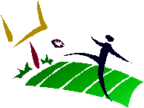
3. A rectangular football field has side lines 100m long. Each of the end lines is 50m long. What is the perimeter of the football field? (2 Marks)

4. Calculate the area of the following shapes to 2 decimal places. (2,2,2,2,3 Marks)

4 cm

a) b)

4.5 cm
7.25 m

12.5 m

2.8 cm
c) d)
19cm

1.5cm

8 cm

18 cm

e) f)
12 cm
45 cm

5. Calculate the area of the sectors below (12 Marks)

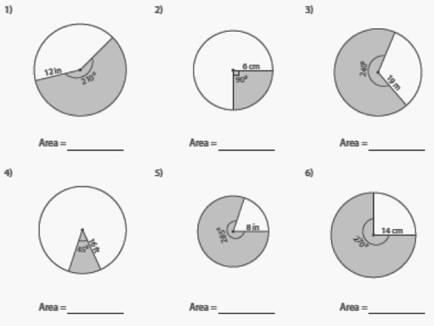

6. Determine the area of the following shapes or shaded shapes. (3,4 marks)

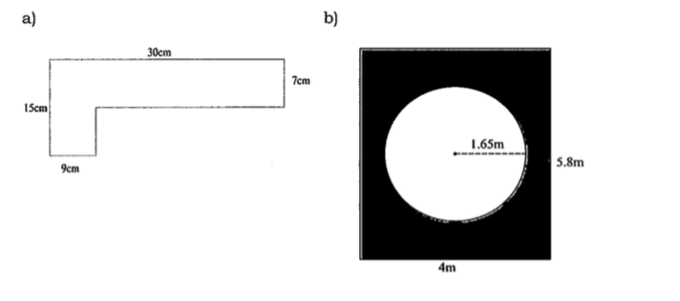

7. Calculate the surface area of the shapes below. (3 ,3 ,2 Marks)
PLEASE SHOW ALL WORKING

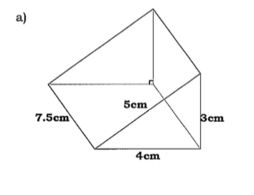

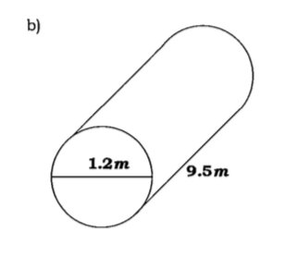

c)

0.12 m

13.5 cm
22 cm

8. A box needs to be covered in brown paper for mailing. If the box measures 3meters by 2 meters by 1.5 meters, what is the surface area of the box that will need to be covered assuming the box is closed? ( 3 Marks)

9. A soup can has a diameter of 8 cm and a height of 10.5 cm. How much metal is needed to make the can? ( 3 Marks)

10. For a project, Kenneth has to cover all sides of a rectangular based pyramid with cloth (excluding the base). The pyramid has the dimensions shown below. How much cloth will Kenneth need to cover the sides of the pyramid? ( 4 Marks)

15cm
11cm
12cm

